**The Sullivan County Honor Guard** May 2019

This is an informational article about the Sullivan County Honor Guard describing its dedication, duties and history. Primarily the guard is dedicated to serving the community by honoring our veterans service to our country and showing respect to their families at a veteran’s military funeral. In addition, the Honor Guard participates in many other community events as described later in this article.

**Eligibility to join the Sullivan County Honor Guard.**

The American Legion has, since its inception in 1919, performed thousands of burial ceremonies annually for families. As such, it has become a sacred obligation of all Americans to honor the deceased veterans by performing these timely honored duties in the best tradition of the decedent’s service. The Sullivan County Honor Guard detail consists of honorably discharged wartime veterans. They are required to be a member of one of the three American Legions, Sullivan Post 139, Shelburn Post 197, Hymera Post 298 or the Sullivan VFW Post 2459. If interested in joining contact the Sullivan American Legion Post 139.

**The Honor Guard serves our community in many capacities.**

**Military funerals.**

**Overview of the military honors presentation.**

Usually the Honor Guard does a walk through at the facility where the viewing of the Veteran is taking place. This consists of respectfully saluting the veteran as they pass by the casket. Sometimes the American Flag is presented to the next of kin here. After this they proceed to the cemetery. At the cemetery the Honor Guard waits for the funeral party to arrive and after the final words are spoken by clergy the flag is respectfully folded into the symbolic tri-cornered shape. It is then presented as a keepsake to the next of kin or an appropriate family member. Words of gratitude for the veterans honorable and faithful service are spoken. After the flag presentation the firing party, consisting of seven rifles and under the direction of the commander, will fire three volleys. Finally taps is rendered and then the Honor Guard detail is dismissed and marches away from the gravesite. This concludes the military service.

The entire military honors funeral service or a variation of it that is described above may be conducted solely at the funeral home, at a church or at a cemetery per the family’s request.

The following text explains in detail the steps that are followed at the military honors presentation of a Veteran.

**Honor Guard assembles**

When a Veteran dies and the family wishes to have military funeral rites the funeral home in charge will call the Honor Guard commander to inform him or her of the date and time of the funeral. Members are then called by a designated member of the Honor Guard. On the day of the funeral guard members will normally meet forty-five minutes before the funeral at the Sullivan American Legion building where a roll call is taken and members sign a register, which will be given to the next of kin, before proceeding to the site of the service.

**Hearse arrival**

At the grave site the hearse carrying the Veteran arrives and parks adjacent to the grave site. The pallbearers take their position at the rear of the hearse. As they start removing the casket the commander orders the Honor Guard, which are members holding flags or non-firing rifles, and the Firing Party to attention and then to “present arms”. This is done to show respect. Once the casket is placed on the stand over the grave the commander gives the order “parade rest”. Parade rest is an attentive body position more relaxed than standing at attention.

**Flags**

The Honor Guard will display the American Flag and local post flags from the VFW and American Legions in their detail formation. The number of flags displayed in the assembly depends on the number of attending members of the Honor Guard that are attending. A United States burial casket flag, which measures 5 feet X 9-1/2 feet, drapes the casket of a deceased veteran to honor the memory of their service to the country. The flag is placed on a closed casket so the union blue field is at the head and over the left shoulder of the deceased. The flag is folded. A properly proportioned flag will fold 13 times on the triangles, representing the 13 original colonies. In addition, each fold has a symbolic meaning. For example: The *first* fold of our flag is a symbol of life. The folded flag is emblematic of the tri-cornered hat worn by the

Patriots of the American Revolution. When folded, no red or white except for the white of the stars is to be evident, leaving only the blue field with stars. The ceremonial folding and presentation of the flag is a moving tribute of lasting

importance to the veteran’s family.

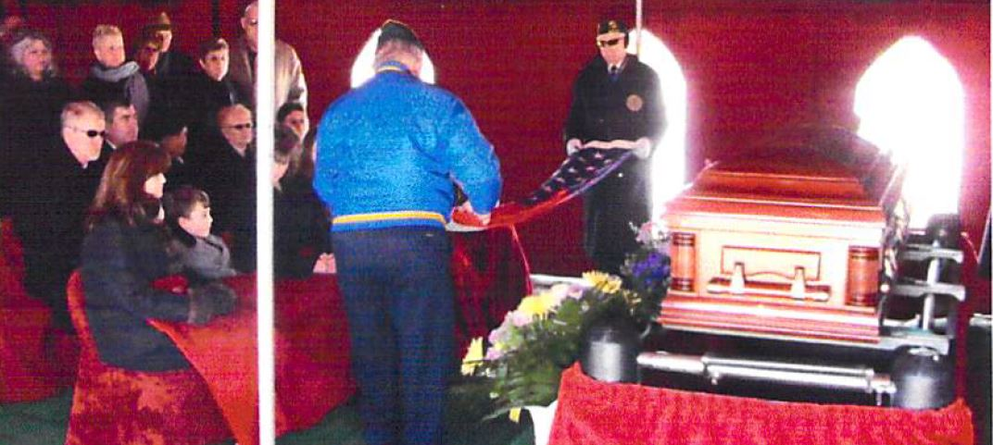

**Folding the flag before it is presented.**

Burial or interment flags are provided free of charge to the families of veterans at the time of burial. The Funeral Home will provide the flag upon verification of service, the DD form 214 or equivalent discharge papers.

**Shell casings symbolism.**

The flag detail often slips three shell casings into the folded flag before presenting the flag to the family or presents them separately to the family. Each casing represents one volley. This gesture provides a slightly different meaning for the symbolism of the three bullets in a military funeral. These shell cases symbolize that the deceased received full military honors. Some say that the three spent shell casings represent *Duty, Honor and Country.*

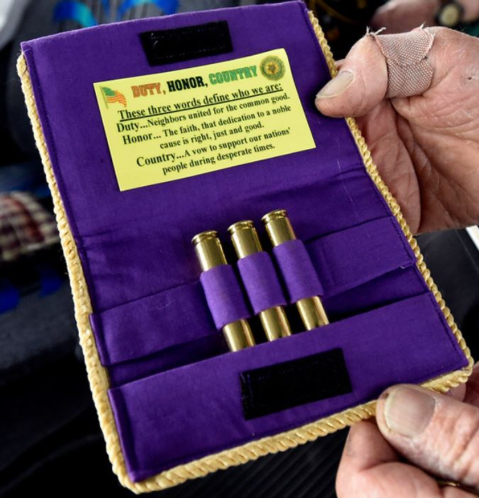

**Three bullet casings presented to family.**

**Words often spoken during the flag presentation.**

**“On behalf of the President of the United States, (the United States Army; the United States Marine Corps; the United States Navy; the United States Air Force, or the United States Coast Guard), and a grateful Nation, please accept this flag as a symbol of our appreciation for your loved one’s honorable and faithful service.”**

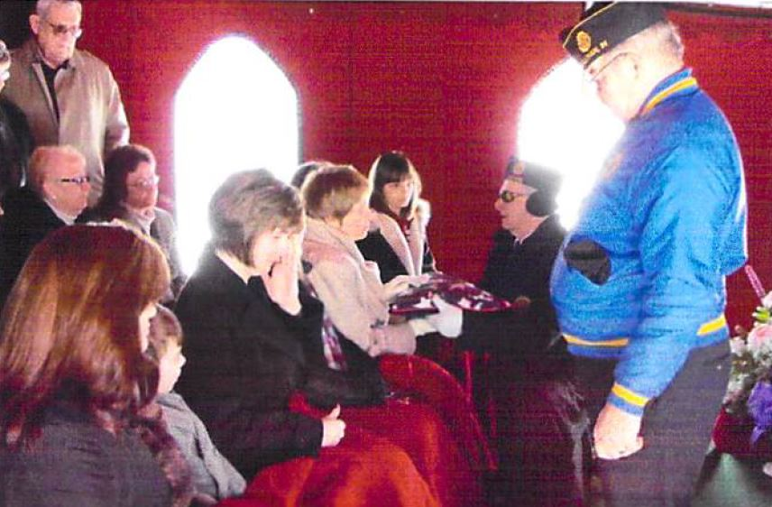

**Presenting the flag to the next of kin.**

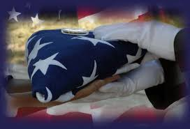

**Properly folded flag being presented.**

**Rifle volley symbolism.**

Military funeral honors may or may not include the firing of three rifle volleys over the grave during interment. It depends on the families wishes. The firing of three volleys over the grave of a fallen warrior has its origin in the old custom of halting the fighting to remove the dead from the battlefield. Once the dead were removed, three-musket volleys were fired as a signal that the battle could resume. A firing party of seven members traditionally fires the volleys using rifles.

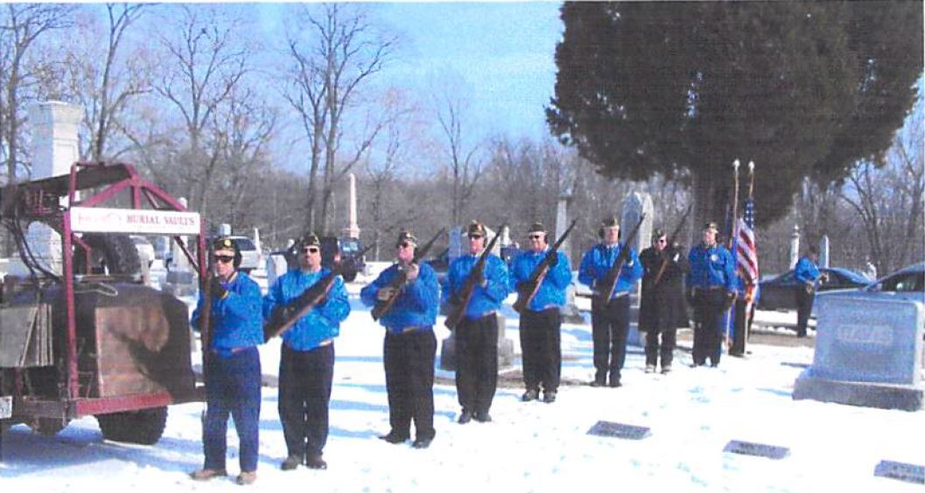

**Firing squad at “port arms” position ready to fire one of three volleys at a military funeral.**

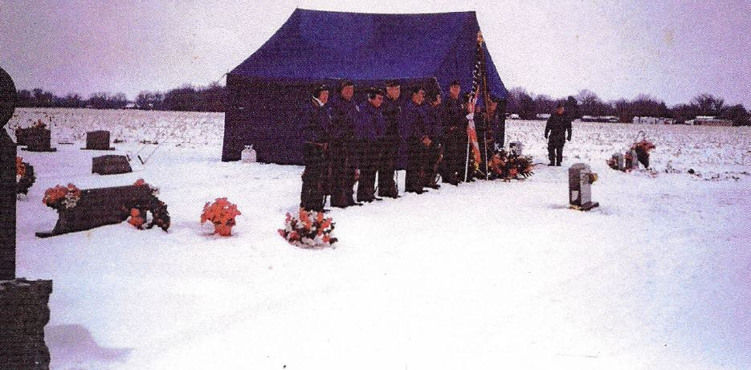

**Christmas Eve 1995 Westlawn Cemetery Claude Wheat gravesite memorial tribute.**

**Taps symbolism.**

Taps was composed by General Daniel Butterfield of the Union Army during The Civil War. Originally composed to signal “lights out” the somber tune became a traditional way to honor servicemembers, eventually becoming a staple at funeral services to honor the extinguishing of a life.

After Taps the Honor Guard Detail is dismissed and concludes the military rites portion of the funeral service.

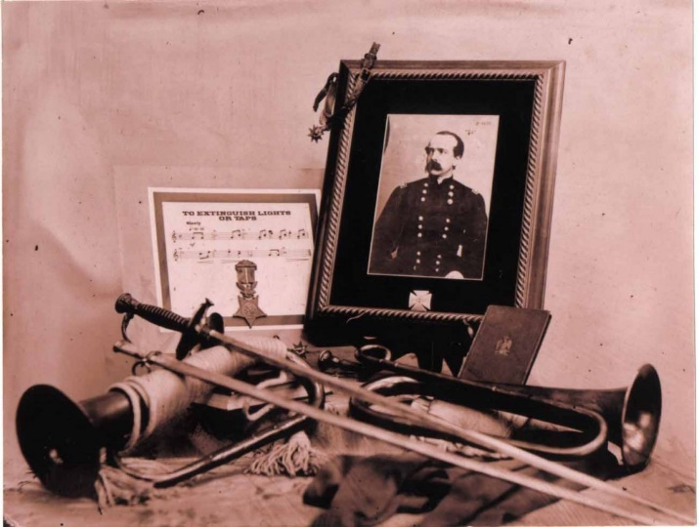

**General Butterfield**

**General Butterfield** with the help of the brigade bugler, **Oliver Willcox Norton** (1839-1920), wrote Taps to honor his men while in camp at Harrison’s Landing, Virginia, following the Seven Days battle. These battles took place during the Peninsular Campaign of 1862. The new call, sounded that night in July, 1862, soon spread to other units of the Union Army and was reportedly also used by the Confederates. Taps was made an official bugle call after the war.

**Community Events that the Honor Guard is active in.**

**Memorial Day Ceremony**

Annually the Honor Guard and citizens will gather at the Sullivan Square to remember and honor those who gave the ultimate sacrifice. The boy scouts are in charge of the American flag protocol. After the speakers, the laying of the wreaths by veteran’s organizations and others, prayer a traditional rifle volley of three shots is presented followed by taps is given by the Honor Guard.

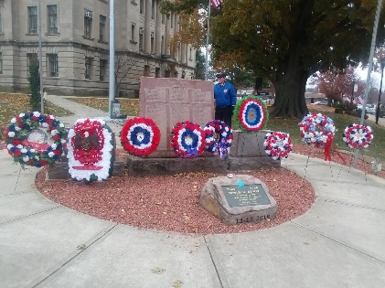

**Wreaths laid at the flag pole.**

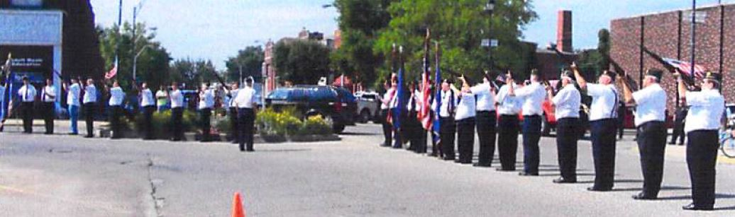

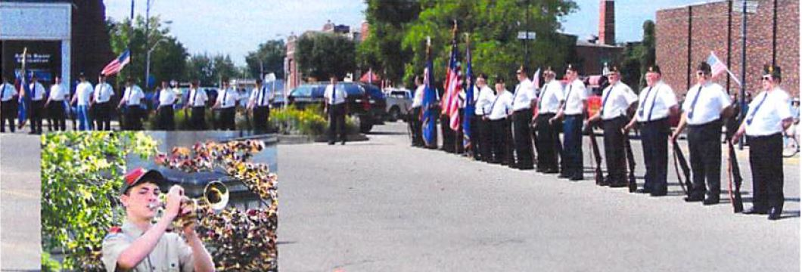

**Honor Guard rifle volley and taps.**

**Corn Festival Parade**

During the September Corn Festival, the Honor Guard marches to honor and represent our military who by their faithful service have kept this country free and safe.

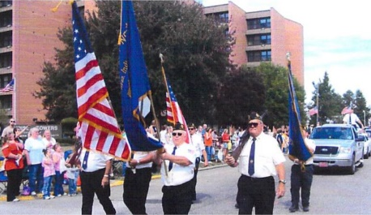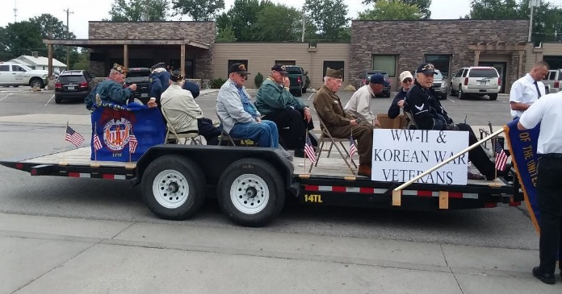

**Honor Guard WW-II and Korean War Veterans**

**Veteran’s Day Ceremony**

Annually the Honor Guard and citizens will gather at the Sullivan Square to recognize veterans who have served our country. The boy scouts are in charge of the American flag protocol. After the speakers and prayer, the Honor Guard presents the traditional rifle volley of three shots followed by taps.

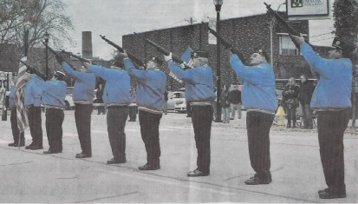

**Rifle volley by the Honor Guard.**

**See you at the Pole**

The Color Guard participates in “See You at the Pole”.

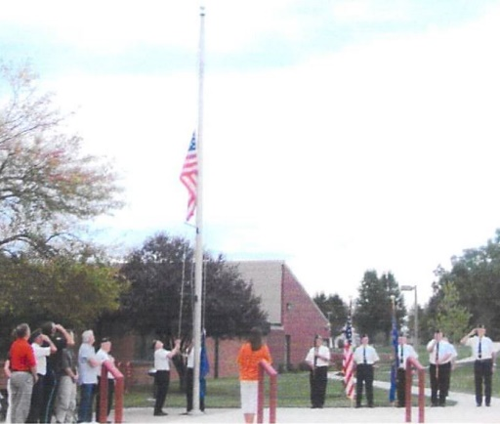

**Color Guard at Carlisle School.**

**Ralph Dale’s tribute to Shelburn Area Veterans.**

Memorial to Shelburn area Veterans past, present and future. Started in 2016 Pearl Harbor 75th anniversary.

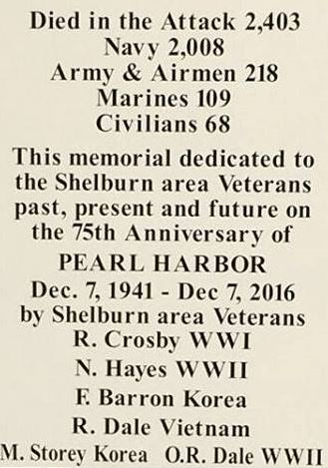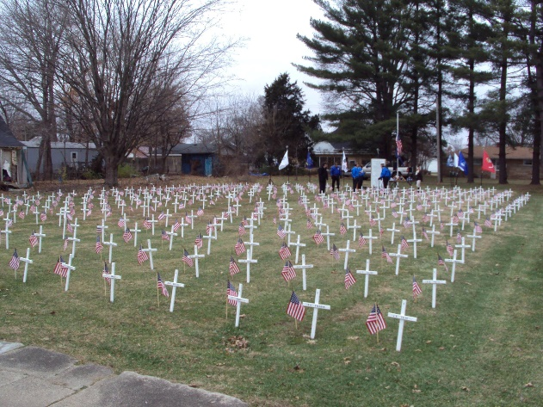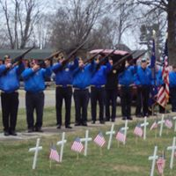

**Honor Guard presenting at Ralph Dale’s tribute.**

**Farmersburg Christmas Parade**

Fun time for the kids and family with Santa Claus making an appearance in the parade.

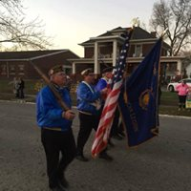

**Marching east on Main Street, Farmersburg.**

**Respectfully disposing of worn out flags.**

The Honor Guard assembles at the Sullivan American Legion to burn flags.

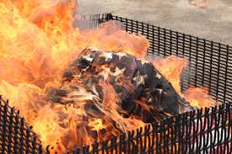

**Flags disposed of in a burn pit.**

**History of the Sullivan County Honor Guard.**

Before Sullivan Post 139, Shelburn Post 197, Hymera Post 298 and Sullivan VFW Post 2459 combined into one honor guard some posts had their own honor guard/funeral detail.

**I was informed that the Posts listed below had their own funeral detail or honor guard. Unfortunately, we do not have any pictures or articles for all of these.**

**Carlisle American Legion.**

**Did Dugger American Legion have their own Honor Guard?**

**Hymera American Legion.**

**Fairbanks American Legion.**

**Did Merom American Legion have their own Honor Guard?**

**Shelburn American Legion – see picture below.**

**Sullivan American Legion.**

**Sullivan VFW has done funerals independent of our County Honor Guard.**

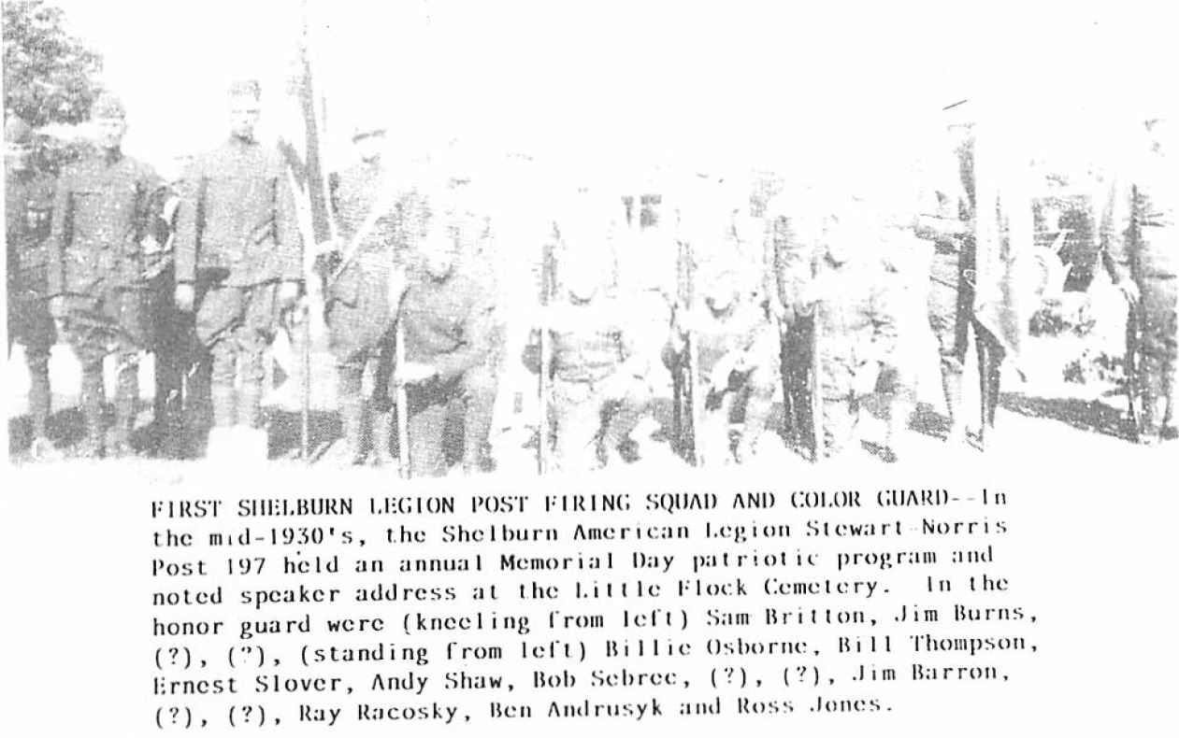

**Shelburn Legion Post 197 Honor Guard – 1930’s vintage.**

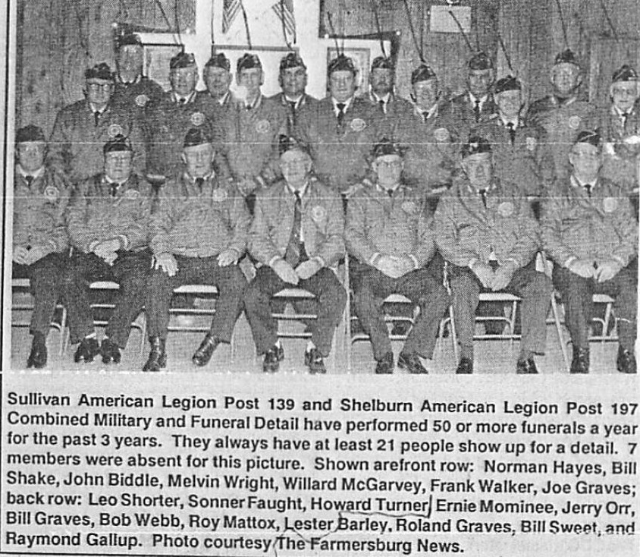**Sullivan Post 139 and Shelburn Post 197 combined.**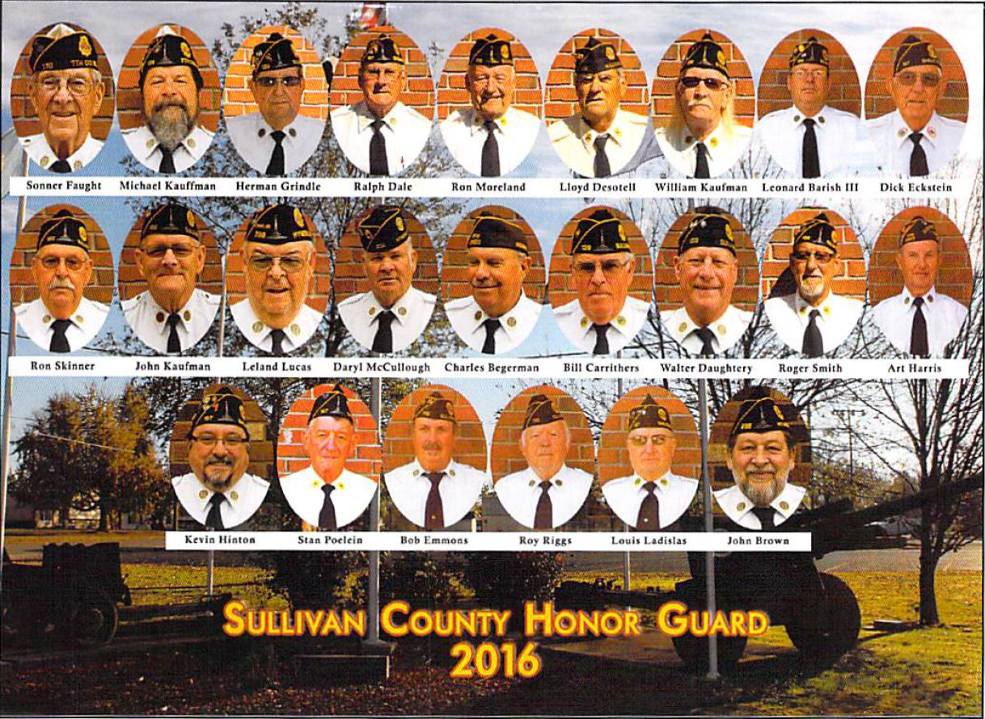

American Legion Posts - Sullivan 139, Shelburn 197, Hymera 298 and the Sullivan VFW Post 2459

American Legion Posts - Sullivan 139, Shelburn 197, Hymera 298 and the Sullivan VFW Post 2459

Credits:

Sullivan County Veterans Affairs Office

Ron Gadberry

Sullivan Museum

Ralph Dale

Walt Daugherty